|  |  |
| --- | --- |
|  | | Process Definition Document |

Extract Random Weather

Date: 08-09-2025

**Process Design Document History**

|  |  |  |  |  |  |  |  |
| --- | --- | --- | --- | --- | --- | --- | --- |
| Date | Version | Role | Name | Organization | Function | Comments | |
| 08.09.2025 | **1.0** | **Author** | **Amr Ayman** | **Raya IT** | **BA,RPA Developer** | | **Creation v1.0** |
|  |  |  |  |  |  | |  |

# Table of Contents

| Process Definition Document 0

Table of Contents 1

I. Introduction 2

I.1 Purpose of the document 2

I.2 Objectives 2

I.3 Process key contact 3

II. As-Is process description 4

II.1 Process Overview 4

II.2 Standard Of Metrics 4

II.3 Applications used in the process 5

II.4 Business Rules 5

II.5 As-Is Process map 6

II.6 Detailed As-Is Process Actions 8

II.7 Exceptions Handling 22

III. To-Be Process Description 23

III.1 In Scope of RPA 23

III.2 Out of Scope of RPA 23

IV. Other Observations 24

IV.1 Systems 24

IV.2 Reporting 24

# Introduction

## I.1 Purpose of the document

The Process Definition Document outlines the business process chosen for automation using UiPath Robotic Process Automation (RPA) technology.

The document describes the sequence of actions performed as part of the business process, the conditions and rules of the process prior to automation and how they are envisioned to work after automating it, partly or entirely. This specifications document serves as a base for developers, providing them with the details required for applying robotic process automation to the selected business process.

## I.2 Objectives

The Automation of the full process of extract random weather task , reducing the human interaction to zero, the system will operate seamlessly through the edge web browser delivering faster processing, reducing the duration time of time-consuming activities and improving overall performance and reliability

|  |  |
| --- | --- |
| Objectives | Expected Benefits |
| Automate the full Extract weather Information | **Eliminate manual intervention, ensuring end-to-end seamless execution.** |
| Reduce human interaction to zero | **Minimize errors from manual handling, improve compliance and accuracy** |
| Accelerate processing speed of verification tasks | **Shorten overall task cycle time, enabling faster turnaround for stakeholders** |
| Reduce duration of time-consuming activities | **Free up staff capacity for higher-value activities, leading to productivity gains** |
| Improve overall performance | **Standardized processes, ensuring consistency and scalability** |
| Increasing system reliability through automation | **Lower risk of process failure, improve trust in system outputs** |
| Support continuous operations with minimal downtime | **Enhance operational efficiency and customer satisfaction** |

## I.3 Process key contact

|  |  |  |  |
| --- | --- | --- | --- |
| ****Role**** | ****Name**** | ****Contact details (email, phone number)**** | ****Notes**** |
| **RPA Developer / BA** | **Amr Ayman** | **amr@raya.com** |  |
| **SME** | **Eng. Mohamed Mesbah** | **M.Mesbah@gmail.com** | **Contact for questions, details, approvals** |

# As-Is process description

## II.1 Process Overview

The Extract weather information is currently performed manually across edge web browser, the employee must open the edge web browser go search for generate random weather and go to the first link , apply weather specifications and generate it , then extract the info and put it into txt file.

Due to the high level of manual intervention, the task is time-consuming, error-prone, and dependent on staff availability, often leading to delays in verification, inconsistent outputs, and operational inefficiencies. Additionally, manual handling increases the risk of overlooking discrepancies, requiring additional rework and cross-departmental follow-ups.

## II.2 Standard Of Metrics

|  |  |  |
| --- | --- | --- |
| **#** | **Item** | **Description** |
| 1 | **Process full name** | **Extract Random Weather** |
| 2 | **Process Area** | **Weather Generation** |
| 3 | **Department** | **Weather Generation** |
| 4 | **Process short description (operation, activity, outcome)** | **Search for weather random generator, choose the weather options to be warm , winter , rare , generate the weather then extract info and save to txt file** |
| 5 | **Role(s) required for performing the process** | **1** |
| 6 | **Process schedule and frequency** | **Everyday at 8:00 am** |
| 7 | **# of items processed /reference period** | **1** |
| 8 | **Process execution time** | **1 min** |
| 9 | **Peak period (s)** | **NA** |
| 10 | **Transaction Volume During Peak period** | **NA** |
| 11 | **Total # of FTEs supporting this activity** | **1** |
| 12 | **Expected increase of volume in the next reference period** | **NA** |
| 13 | **Level of exception rate** | **5%** |
| 14 | **Input data** | **Weather climate, weather season, weather** |
| 15 | **Output data** | **Txt file with all weather information** |
| **15** | **Return on Investment** | **Reduce the processing time by 80% and FTE to zero** |

## II.3 Applications used in the process­

|  |  |  |  |  |  |
| --- | --- | --- | --- | --- | --- |
| # | Application name & version | System Language | Thin/Thick Client | Environment/ Access method | Comments |
| **1** | **Edge Browser** | **English** | **Thick** | **Desktop App** | **Majority of processing** |

## II.4 Business Rules

|  |  |
| --- | --- |
| Business Rule | Description |
| BR-01 | **Employee must use the first link appears after search** |
| BR-02 | **The employee must extract maininfo and description separetly** |
| BR-03 | **The employee must save new file for everyday** |

## II.5 As-Is Process map

### High Level As-Is Process Map:

This chapter depicts the As-Is business process at a High Level to enable developers to have a high-level understanding of the current process.

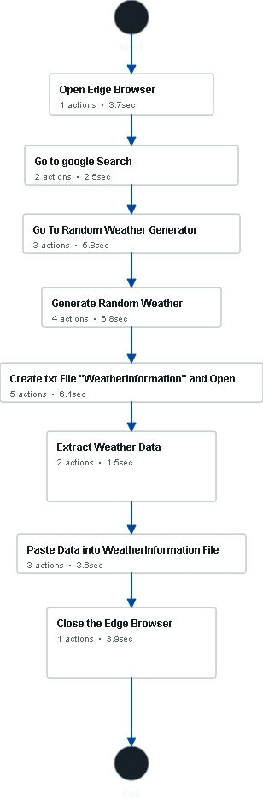

### Detailed As-Is Process Map:

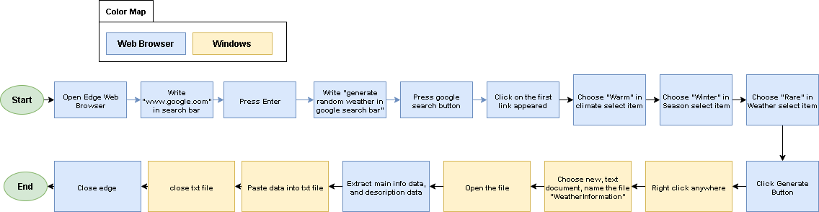

|  |  |
| --- | --- |
| Step | Short Description |
| 1.1 | Open Edge Browser |
| 2.1 | Write www.google.com in the search bar |
| 2.2 | Press the Enter key |
| 3.1 | Write "generate random weather" in the Google search bar |
| 3.2 | Click the Google Search button |
| 3.3 | Click on the first link |
| 4.1 | Change the Climate select item to "Warm" |
| 4.2 | Change the Season to "Winter" |
| 4.3 | Change the Weather to "Rare" |
| 4.4 | Click the Generate button |
| 5.1 | Right-click anywhere on the screen |
| 5.2 | Choose "New" |
| 5.3 | Choose "Text Document" |
| 5.4 | Name the file "**WeatherInformation**" |
| 5.5 | **Open** the file |
| 6.1 | **Extract** the **Weather Main Info** |
| 6.2 | **Extract** the **Weather Description** |
| 7.1 | **Paste** the **Weather MainInfo** |
| 7.2 | **Paste** the **Weather Description** |
| 7.3 | **Close** the text file |
| 8.1 | **Close** the Edge Browser |

## II.6 Detailed As-Is Process Actions

#### Open Edge Browser

|  |  |
| --- | --- |
|  | **Est. time: 3.7 sec.** |

##### Open edge Browser

|  |  |
| --- | --- |
|  | **Est. time: 3.7 sec.** |
| image | Action: Keyboard Input |

#### Go to google Search

|  |  |
| --- | --- |
|  | **Est. time: 2.5 sec.** |

##### Write www.google.com in search bar

|  |  |
| --- | --- |
|  | **Est. time: 0.5 sec.** |
| image | Action: Special Key |

##### Press Enter

|  |  |
| --- | --- |
|  | **Est. time: 1.10 sec.** |
| image | Action: Special Key |

#### Go To Random Weather Generator

|  |  |
| --- | --- |
|  | **Est. time: 5.8 sec.** |

##### Write "generate random weather" in google search bar

|  |  |
| --- | --- |
|  | **Est. time: 0.6 sec.** |
| image | Action: Special Key |

##### Press Google Search button

|  |  |
| --- | --- |
|  | **Est. time: 3.1 sec.** |
| image | Action: Click |

##### Click On first link

|  |  |
| --- | --- |
|  | **Est. time: 2.1 sec.** |
| image | Action: Click |

#### Generate Random Weather

|  |  |
| --- | --- |
|  | **Est. time: 6.8 sec.** |

##### Change Climate select item to "Warm"

|  |  |
| --- | --- |
|  | **Est. time: 1.10 sec.** |
| image | Action: Click |

##### Change Season to "Winter"

|  |  |
| --- | --- |
|  | **Est. time: 1.4 sec.** |
| image | Action: Click |

##### Change Weather to "Rare"

|  |  |
| --- | --- |
|  | **Est. time: 0.8 sec.** |
| image | Action: Click |

##### Click Generate Button

|  |  |
| --- | --- |
|  | **Est. time: 2.6 sec.** |
| image | Action: Click |

#### Create txt File "WeatherInformation" and Open

|  |  |
| --- | --- |
|  | **Est. time: 6.1 sec.** |

##### Right Click in anywhere

|  |  |
| --- | --- |
|  | **Est. time: 0.9 sec.** |
| image | Action: Click |

##### Choose New

|  |  |
| --- | --- |
|  | **Est. time: 1.5 sec.** |
| image | Action: Click |

##### Choose Text Document

|  |  |
| --- | --- |
|  | **Est. time: 1.7 sec.** |
| image | Action: Click |

##### Name The File "WeatherInformation"

|  |  |
| --- | --- |
|  | **Est. time: 0.3 sec.** |
| image | Action: Keyboard Input |

##### Open The file

|  |  |
| --- | --- |
|  | **Est. time: 1.7 sec.** |
| image | Action: Click |

#### Extract Weather Data

|  |  |
| --- | --- |
|  | **Est. time: 1.5 sec.** |

##### Extract Weather Main Info

|  |  |
| --- | --- |
|  | **Est. time: 0.2 sec.** |
| image | Action: Hotkey |

##### Extract Weather Description

|  |  |
| --- | --- |
|  | **Est. time: 1.3 sec.** |
| image | Action: Click |

#### Paste Data into WeatherInformation File

|  |  |
| --- | --- |
|  | **Est. time: 3.6 sec.** |

##### Paste Weather MainInfo

|  |  |
| --- | --- |
|  | **Est. time: 0.2 sec.** |
| image | Action: Hotkey |

##### Paste weather Description

|  |  |
| --- | --- |
|  | **Est. time: 0.3 sec.** |
| image | Action: Hotkey |

##### Close the txt File

|  |  |
| --- | --- |
|  | **Est. time: 3.2 sec.** |
| image | Action: Click |

#### Close the Edge Browser

|  |  |
| --- | --- |
|  | **Est. time: 3.9 sec.** |

|  |  |
| --- | --- |
|  | **Est. time: 3.9 sec.** |
| image | Action: Click |

#### End

|  |  |
| --- | --- |
|  | **Est. time: 0.0 sec.** |

## II.7 Exceptions Handling

|  |  |  |
| --- | --- | --- |
| # | Exception | Expected Action |
| SE-01 | **Something went wrong when open**  **Web browser** | **Log Message “Failed to open Browser”** |
| BE-01 | **Donjon weather generator not appearing as the first link** | **Refresh browser and type “donjon” after “generate random weather” and click search again** |
| BE-02 | **No data generated after clicking generate** | **Refresh browser and fill info again and click generate** |

# To-Be Process Description

## III.1 In Scope of RPA

The activities **in scope of RPA**, are listed here:

All Actions are in scope of RPA

## III.2 Out of Scope of RPA

The activities **Out of scope of RPA**, are listed here:

**No actions are out of scope of RPA**

# Other Observations

## IV.1 Systems

|  |  |  |
| --- | --- | --- |
| System | Usage | Frequency |
| Edge Browser | **Primary use for process** | **Once / case** |

## IV.2 Reporting

|  |  |  |  |  |
| --- | --- | --- | --- | --- |
| # | Report type | Update frequency | Details | Monitoring Tool to visualise the data |
| 1 | Weather Information txt file | Daily | NA | NA |